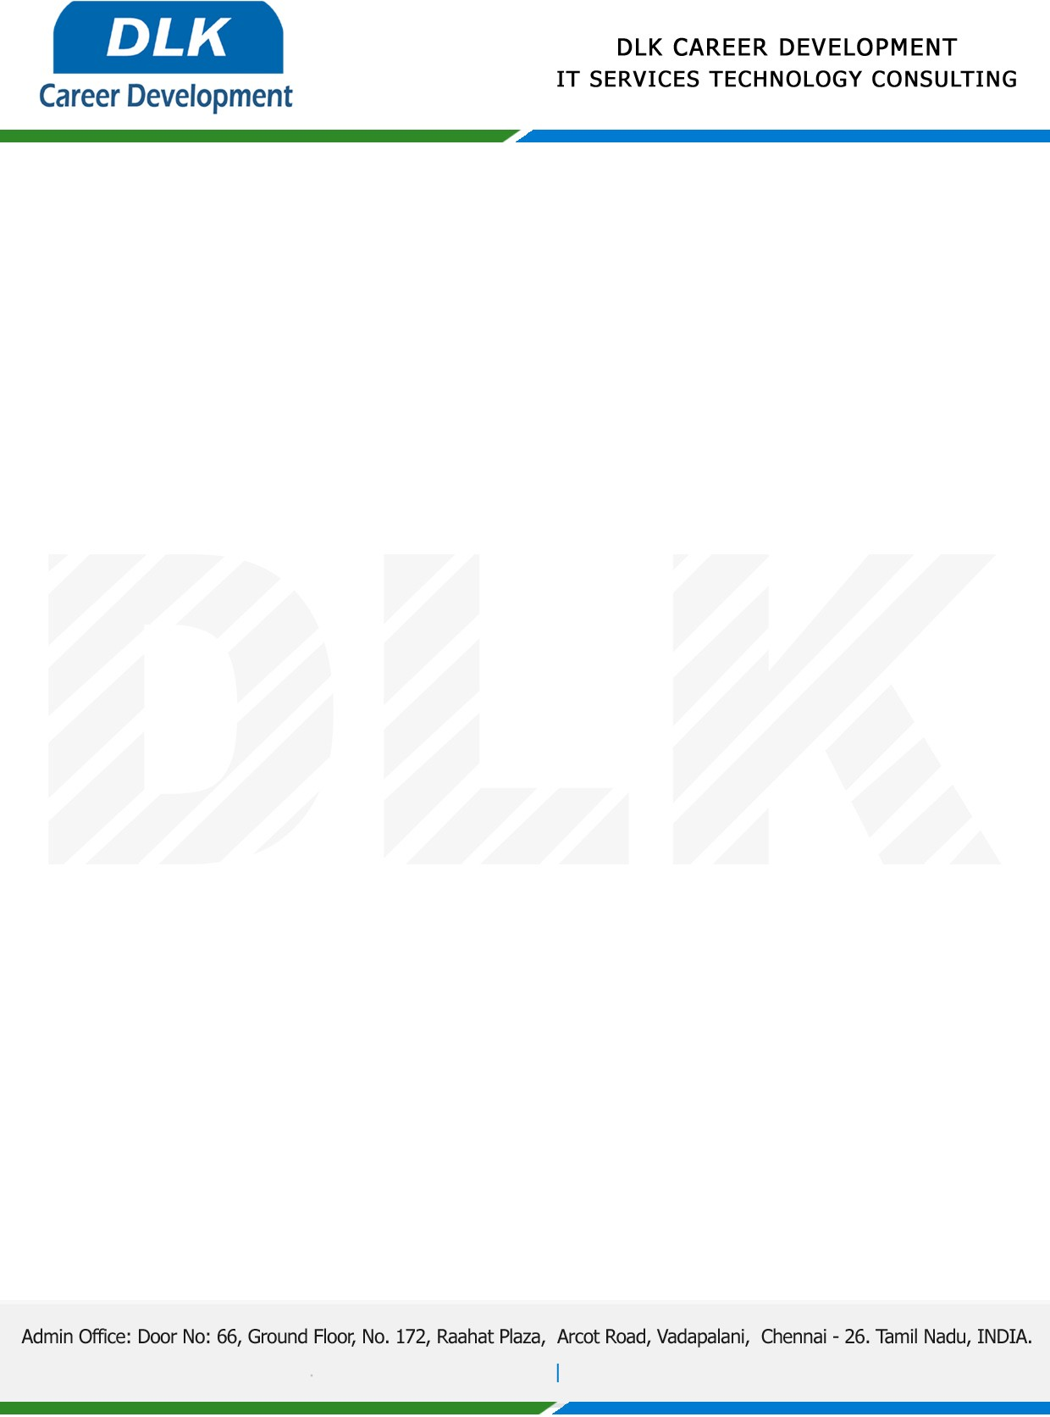

Date: 19/ January / 2023

**To**

Department of BCA ( [Computer Application),](https://www.cseindia.org/)

Head of Department,

Alpha arts and science college, Chennai - 600116.

**Sub: Letter of Project Acceptance**

This is to certify that final year students of has accepted the Project Work duration from **21st**  **January 2023** to **21st April 2023** under the domain **“Java”.** During the Project, all information and data collected from you should be kept confidential.

**Team Members:**

1. MR DHARSHAN C (REG NO: 212002743)
2. MR JAGANATHAN K (REG NO: 212002750)
3. MR KARTHICK H (REG NO: 212002754)

**Topic:** A Verifiable and Fair Attribute-based Proxy Re-encryption Scheme for Data Sharing in Clouds.

We appreciate your interest in **DLK CAREER DEVELOPMENT**

